

CLDV PART 1B

ST10053561



September 1, 2023

Varsity college

[Company address]

**Table of Contents**

Screenshots for Azure Deployment 2

HYPERLINK FOR WEBSITE: 11

Dummy Data To Test: 11

**Table of Figures**

Azure HTTP Trigger 1 : Going to Azure Portal 3

Azure HTTP Trigger 2 : Creating a Function App 3

Azure HTTP Trigger 3 : Creating a Function 4

Azure HTTP Trigger 4 : Function App Storage 5

Azure HTTP Trigger 5 : Function App Networking 5

Azure HTTP Trigger 6 : Function App Monitoring 6

Azure HTTP Trigger 7 : Function App Deployment 6

Azure HTTP Trigger 8 : Function App Tags 7

Azure HTTP Trigger 9 : Function App Create 7

Azure HTTP Trigger 10 : Deployment Success 8

Azure HTTP Trigger 11 : Publishing From VS 8

Azure HTTP Trigger 12 : Selecting as Azure Function 9

Azure HTTP Trigger 13 : Function Instance 9

Azure HTTP Trigger 14 : Profile Creating Process 10

Azure HTTP Trigger 15 : Successfully HTTP Trigger 10

Azure HTTP Trigger 16 : Inserting Correct Password 10

Azure HTTP Trigger 17 : Inserting correct ID. 11

Azure HTTP Trigger 18 :giving wrong ID value. 11

Azure HTTP Trigger 19 : ID is not stored. 11

Azure HTTP Trigger 20: Passport is not stored. 11

Azure HTTP Trigger 21 : Invalid Passport Number 11

## Screenshots for Azure Deployment

Azure HTTP Trigger : Going to Azure Portal

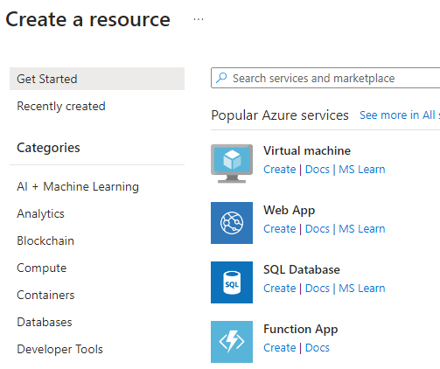

Azure HTTP Trigger : Creating a Function App

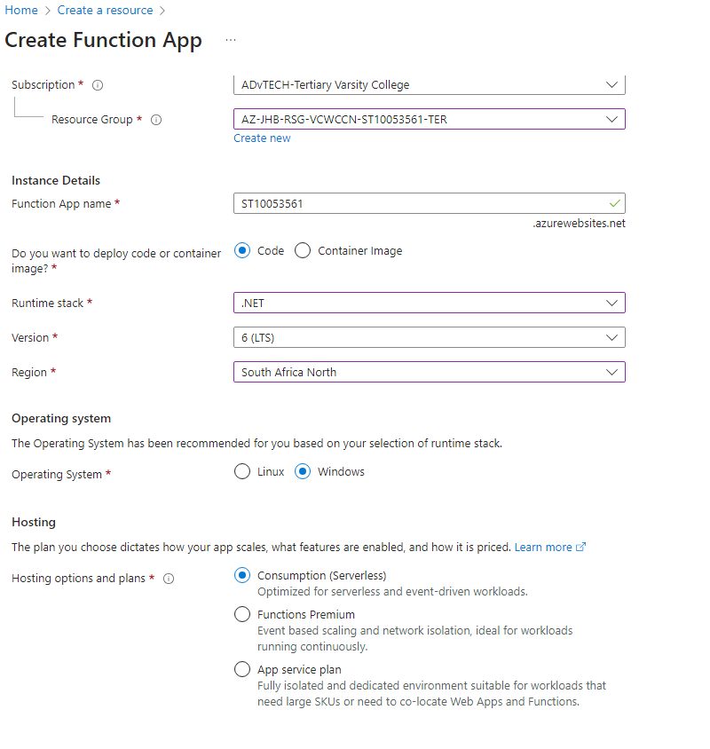

Azure HTTP Trigger : Creating a Function

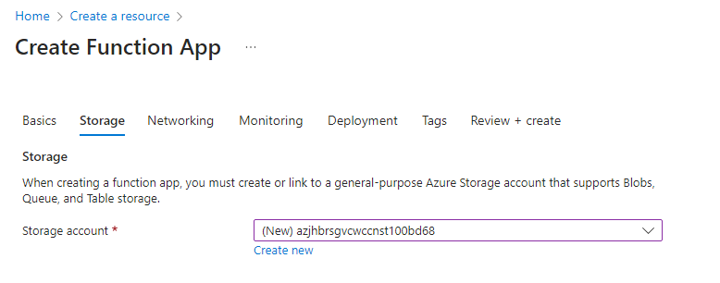

Azure HTTP Trigger : Function App Storage

Azure HTTP Trigger : Function App Networking

Azure HTTP Trigger : Function App Monitoring

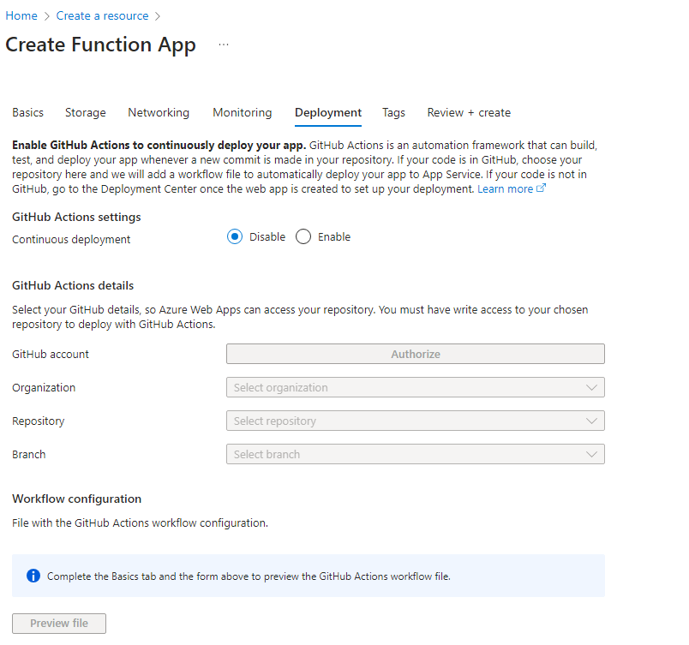

Azure HTTP Trigger : Function App Deployment

Azure HTTP Trigger : Function App Tags

Azure HTTP Trigger : Function App Create

Azure HTTP Trigger : Deployment Success

Azure HTTP Trigger : Publishing From VS

Azure HTTP Trigger : Selecting as Azure Function

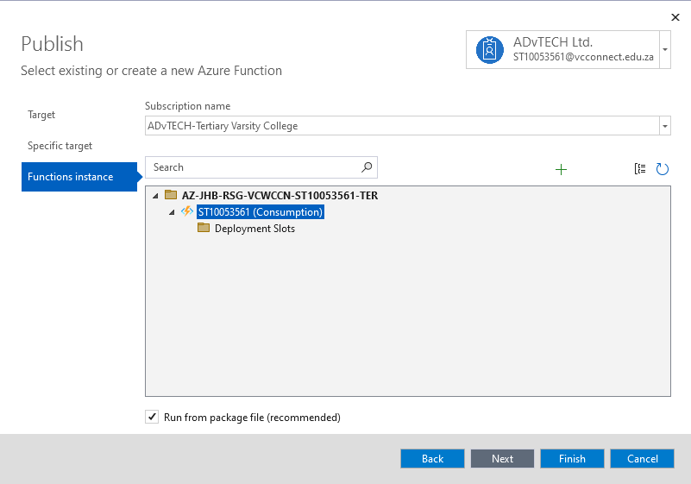

Azure HTTP Trigger : Function Instance

Azure HTTP Trigger : Profile Creating Process

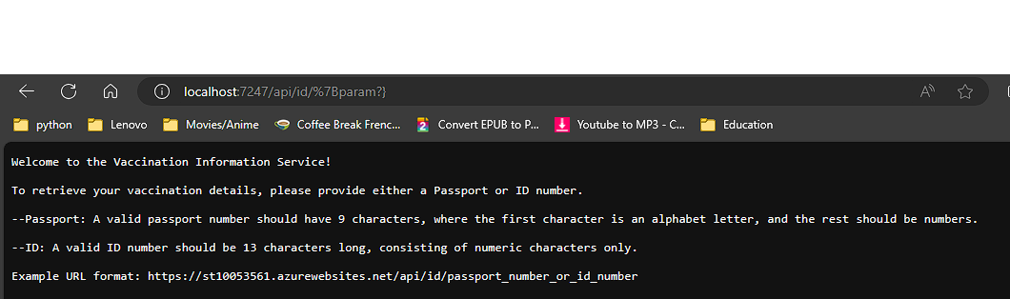

Azure HTTP Trigger : Successfully HTTP Trigger

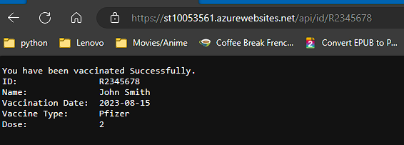

Azure HTTP Trigger : Inserting Correct Password

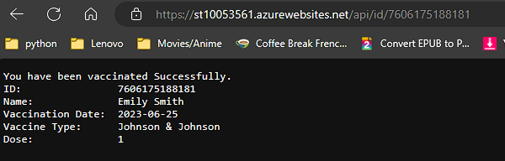

Azure HTTP Trigger : Inserting correct ID.

Azure HTTP Trigger :giving wrong ID value.

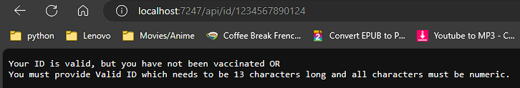

Azure HTTP Trigger : ID is not stored.

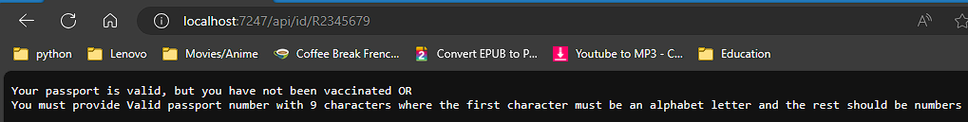

Azure HTTP Trigger : Passport is not stored.

Azure HTTP Trigger : Invalid Passport Number

## HYPERLINK FOR WEBSITE:

[st10053561.azurewebsites.net/api/id/%7Bparam?}](https://st10053561.azurewebsites.net/api/id/%7Bparam?%7d)

Dummy Data To Test:  
Passport No: R2345678, M98765432, S45678901, A23456789, T98765432

ID No: 1234567890123, 9607225921181, 7606175188181, 4208074597183, 8206124609185